Applied Machine Learning

Assignment 2
Linear Regression

FAROOQ AHMAD
17L 4407
BEE 7B

Predicting House Prices (One feature)
In this part we will use data on house sales in King County, where Seattle is located, to predict house prices using simple (one feature) linear regression. You will:
- Use the kc_house_data.csv for this assignment. The dataset is already split into test and train data. Use the kc_house_train_data.csv to build your model and kc_house_test_data.csv to measure its performance.

- Firstly, load the dataset

import pandas
import numpy as np
df1=pandas.read_csv('./kc_house_data.csv')
df2=pandas.read_csv('./kc_house_train_data.csv')
df3=pandas.read_csv('./kc_house_test_data.csv')

- Explore the dataset. Plot different features of the dataset against the sale price to visualize the correlations in the data

print(df1)
plt.scatter(df1['sqft_living'],df1['price'])
plt.title('Features')
plt.ylabel('price')
plt.xlabel('sqft living')
plt.show()

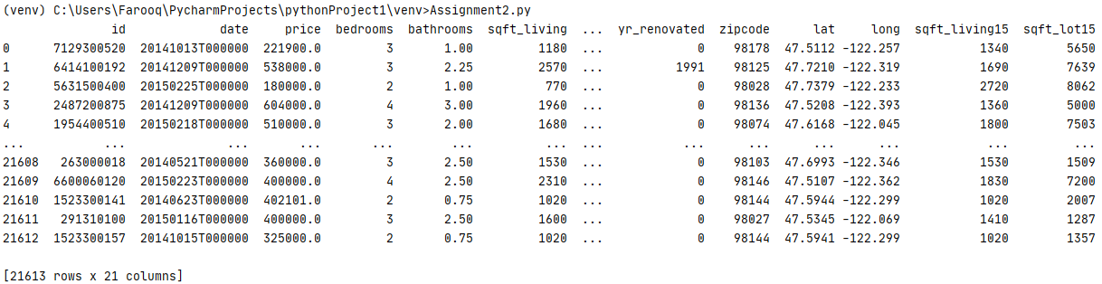
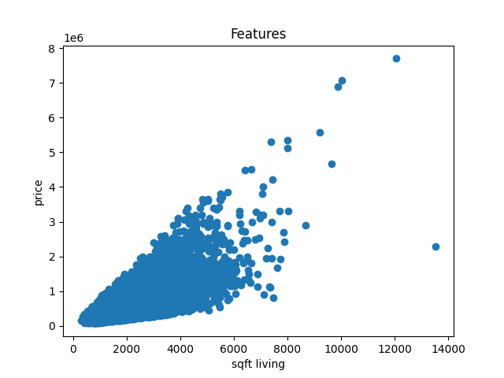
plt.scatter(df1['bedrooms'],df1['price'])
plt.title('Features')
plt.ylabel('price')
plt.xlabel('Bedrooms')
plt.show()

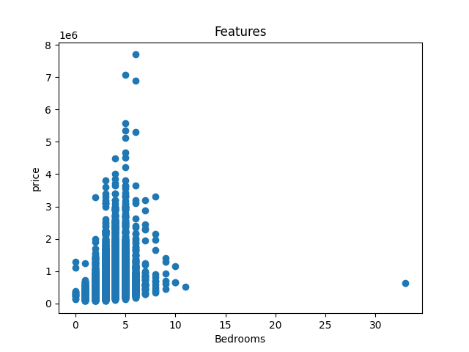
3. Implement a python function for Simple regression model with single feature. Write a generic function that accepts a column of data (e.g, an Array) ‘input_feature’ and another column ‘output’ and returns the Simple Linear Regression parameters ‘intercept’ and ‘slope’. Use the Gradient descent method discussed in the class.
4. Use “sqft_living” to train the Simple Regression model for predicting house sale price.

- Write a function to compute the Simple Linear Regression weights using the gradient descent method discussed in the class.
- Write a function to make predictions of the output given the input feature

import pandas
import numpy as np
import matplotlib.pyplot as plt
df1=pandas.read_csv('./kc_house_data.csv')
df2=pandas.read_csv('./kc_house_train_data.csv')
df3=pandas.read_csv('./kc_house_test_data.csv')
#analogy hypothesis h0(x)= theta0+theta1x as y=mx+c
# Building the function model
slope = 1
intercept = 1
L = 0.00000001 # The learning Rate
loop = 5000 # The number of iterations to perform gradient descent
input_feature = df2['sqft_living'] #X
output = df2['price'] #Y
m = float(len(output)) - 1 # Number of elements in X
# Performing Gradient Descent
for i in range(loop):
Prediction = slope * input_feature + intercept # The current predicted value of Y
D_m = (-2 / m) * sum(input_feature * (output - Prediction)) # Derivative wrt slope
D_c = (-2 / m) * sum(output - Prediction) # Derivative wrt intercept
slope = slope - L * D_m # Update slope
intercept = intercept - L * D_c # Update intercept
print('Returning slope and intercept : ')
print(slope, intercept)
# Making predictions
# Making the prediction function
Prediction = slope*input_feature + intercept
print('Returning Minimum Price')
print(min(Prediction))
plt.scatter(input_feature, output)
plt.plot([min(input_feature), max(input_feature)], [min(Prediction), max(Prediction)], color='red') # regression line
plt.show()

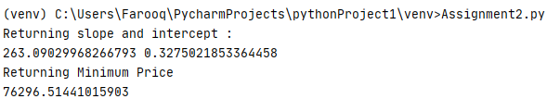
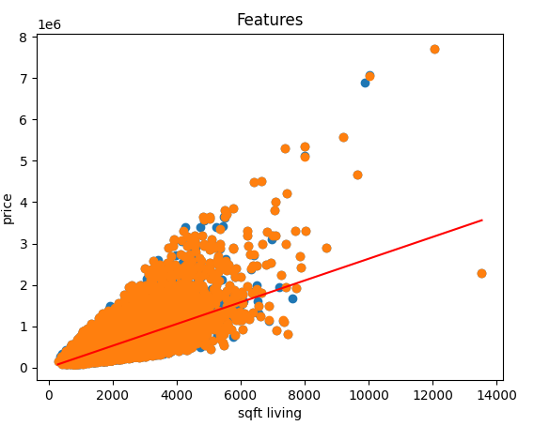
5. Use test data to measure the performance of your model. To report the performance use RSS (Residual sum of squares). RSS or the sum of squared errors of prediction (SSE), is the sum of the squares of residuals (deviations predicted from actual empirical values of data). It is a measure of the discrepancy between the data and an estimation model. A small RSS indicates a tight fit of the model to the data.

Just need to replace the data set. Insert test data set instead of train data set and test the trained data.
Replace df2 with df3
df1=pandas.read_csv('./kc_house_data.csv')
df2=pandas.read_csv('./kc_house_train_data.csv')
df3=pandas.read_csv('./kc_house_test_data.csv')
input_feature = df3['sqft_living'] #X
output = df3['price'] #Y

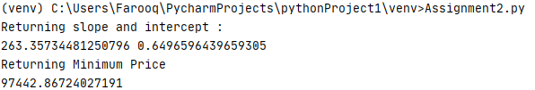
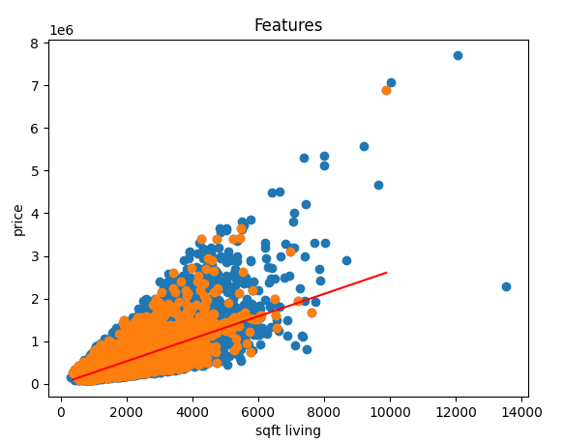

6. Instead of using ‘sqft_living’ to estimate prices we could use ‘bedrooms’ (a count of the number of bedrooms in the house) to estimate prices. Using your function from (3) calculate the Simple Linear Regression slope and intercept for estimating price based on bedrooms.
Replacing “sqft_living” with “bedrooms”
plt.scatter(df1['bedrooms'],df1['price'])
plt.title('Features')
plt.ylabel('price')
plt.xlabel('bedrooms')
#plt.show()
#analogy hypothesis h0(x)= theta0+theta1x as y=mx+c
# Building the function model
slope = 1
intercept = 1
L = 0.00000001 # The learning Rate
loop = 5000 # The number of iterations to perform gradient descent
input_feature = df2['bedrooms'] #X
output = df2['price'] #Y

Rest remains the same as part 3
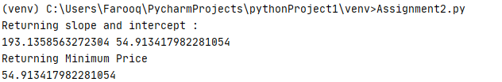

7. Now that we have 2 different models compute the RSS from BOTH models on TEST data.

Just need to replace the data set. Insert test data set instead of train data set and test the trained data.
Replace df2 with df3
plt.scatter(df1['bedrooms'],df1['price'])
plt.title('Features')
plt.ylabel('price')
plt.xlabel('bedrooms')
#plt.show()
#analogy hypothesis h0(x)= theta0+theta1x as y=mx+c
# Building the function model
slope = 1
intercept = 1
L = 0.00000001 # The learning Rate
loop = 5000 # The number of iterations to perform gradient descent
input_feature = df3['bedrooms'] #X
output = df3['price'] #Y

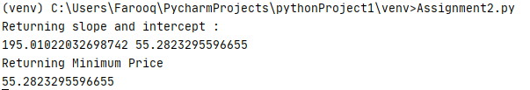
8. Extend the simple univariate model to multiple variable regression model for house prediction.
Using 4 features
import pandas
import numpy as np
import matplotlib.pyplot as plt
from sklearn.preprocessing import StandardScaler
sc=StandardScaler()
df1=pandas.read_csv('./kc_house_data.csv')
df2=pandas.read_csv('./kc_house_train_data.csv')
df3=pandas.read_csv('./kc_house_test_data.csv')

slope = np.zeros(5)
intercept = 1
L = 0.001 # The learning Rate
loop = 5000 # The number of iterations to perform gradient descent
input_feature = df2[['sqft_living','bedrooms','bathrooms','sqft_lot']] #X
n=len(input_feature)
M0 = np.ones((17384,1))
M=input_feature
M=sc.fit_transform(M)
#Mnew=np.c_[M0,input_feature]
Mnew = np.hstack((M0,M))
print(Mnew)
output = df2['price'] #Y
m =float(len(output)) +1 # Number of elements in X
print(m)
# Performing Gradient Descent
for i in range(loop):
Prediction = np.dot(Mnew,np.transpose(slope)) # The current predicted value of Y
#print(Prediction)
cost_function = ( (1/2*m)) * np.sum((Prediction - output)**2)
print(cost_function)
# Derivative wrt slope
slope = slope - ((L / m) * np.dot(np.transpose(Mnew),Prediction - output )) # Update slope
print("Constant value:"+str(cost_function))
print("Theta's Array:"+str(slope))

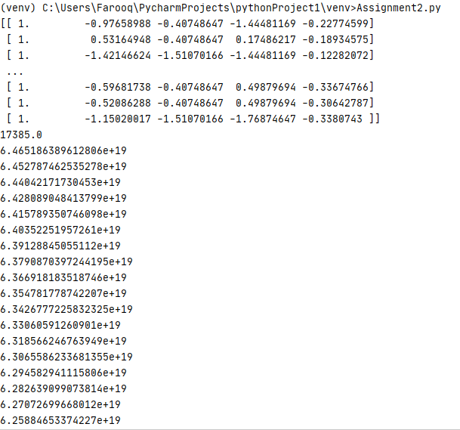
Continued to

  
